**Hello Team!** **Consider the below two tables**:

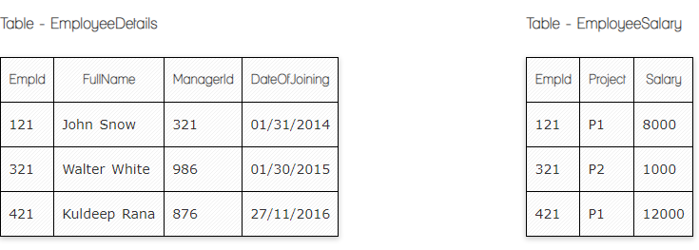

**Ques.1. Write a SQL query to fetch the count of employees working in project 'P1'.**

**Your Answer:**

**Select count(EmpId) from EmployeeSalary**

**Where Project = “P1”**

**Select count(Project)**

**From EmployeeSalary**

**Group By Project**

**Having Project = ‘P1’**

**Ques.2. Write a SQL query to fetch employee names having salary greater than or equal to 5000 and less than or equal 10000.**

**Your Answer:**

**Select ed.FullName from EmployeeSalary es**

**Inner join EmployeeDetails ed On es.EmpId = ed.EmpId**

**Where Salary between 5000 and 10000**

**Where Salary >= 5000 and Salary <= 10000**

**Ques.3. Write a SQL query to fetch count of employees sorted by project's count in descending order.**

**Your Answer:**

**Select count(EmpId), Project from EmployeeSalary**

**Group by Project**

**Order by count(EmpId)**

**Ques.4. Write a query to fetch employee names and salary records. Return employee details even if the salary record is not present for the employee.**

**Your Answer:**

**Select ed.FullName, es.Salary from EmployeeDetails ed**

**Left Join EmployeeSalary es ON On es.EmpId = ed.EmpId**

**Select ed.FullName, es.Salary from EmployeeSalary es**

**Right Join EmployeeDetails ed On es.EmpId = ed.EmpId**

**Ques.5. Write a SQL query to create an empty table with ‘Test’ name.**

**Your Answer:**

**Create Table Test(**

**Testid int primary key**

**Testname varchar(100)**

**Createdby varchar(100)**

**Datecreated timestamp**

**)**

**Ques.6. Write a SQL query to delete an empty table with ‘Test’ name.**

**Your Answer:**

**Drop table Test**

**Ques.7. Write a SQL query to fetch all the Employees details from EmployeeDetails table who joined in Year 2016.**

**Your Answer:**

**Select * from EmployeeDetails**

**Where DateOfJoining like ‘%2016’**

**Ques.8. Write a SQL query to insert new record to the EmployeeDetails table with any data.**

**Your Answer:**

**Insert into EmployeeDetails(FullName, ManagerId,DateOfJoining)**

**Value(Zara, 12, 2004-05-04)**

**Ques.9. Write a SQL query to update EmployeeSalery table with setting Salary to 2000 for Project P2.**

**Your Answer:**

**Update EmployeeSalary**

**Set Salary =2000.**

**Where project=”P2”**

**Ques.10. Write a SQL query to right join both tables and draw the results.**

**Your Answer:**

**Select * from EmployeeDetails ed**

**Right Join EmployeeSalary es On es.EmpId = ed.EmpId**

**Now take these two tables:**

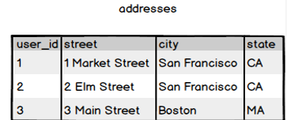

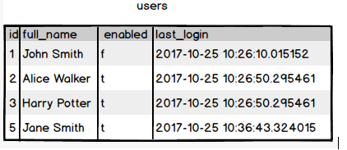

**Ques.11. Write a SQL query to fetch all users full_name from San Francisco.**

**Your Answer:**

**Select full_name from addresses a**

**Inner join users u on a.user_id = u.id**

**Where city like ‘%San Francisco%’**

**Ques.12. Write a SQL query to fetch all users full_name, last_login who are enabled**

**Your Answer:**

**Select full_name, last_login from users**

**Where enabled = ‘t’**

**Ques.13. Write a SQL query to fetch all users full_name who are not from Main street**

**Your Answer:**

**Select full_name from users**

**Join address on addresses.user_id=user.id**

**Where street != ‘Main street’**

**Ques.14. Write a SQL query to fetch all users full_name who are from Main street or San Francisco**

**Your Answer:**

**Select full_name from users**

**Join address on addresses.user_id=user.id**

**Where street = ‘San Francisco’**

**Ques.15. Write a SQL query to fetch user full_name who is equal to user_id from Boston (find user_id value in sub_query)**

**Your Answer:**

**Select full_name from users**

**Where id in (Select user_id from addresses**

**Where city = ‘Boston’)**